No Change
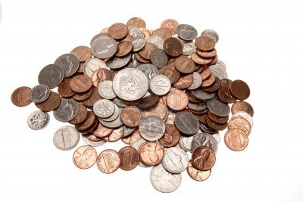
“Give me change for a dollar, please,” said the customer.
“I’m sorry,” said Miss Jones,a the cashier, after searching through the cash register, “I can’t make change for a dollar with the coins that I have here.”
“Can you change a half dollar then?”
Miss Jones shook her head. In fact, she said, she couldn’t even make change for a quarter, dime or nickel!
“Do you have any coins at all?” Asked the customer.
“Oh yes,” said Miss Jones. “I have $1.15 in coins.”
Exactly what coins were in the cash register?

